Background Information
This section goes over research conducted on the amplification technology throughout the years and current design methods. Amplifiers have multiple classes or methods of amplifying audio signals such as class: A, AB, B, B1, B2, G, and D. Class A, B, and G amplifiers all use transistors to directly amplify the audio signal. Class D amplifiers, however, use switches to replicate the input audio signal. Each of the amplifier classes have advantages and disadvantages to better suit specific applications.
Currently, Class D is not widely used in the public and commercial space. The switches utilized in Class D amplifiers were once highly inefficient, rendering Class D amplifiers obsolete in terms of their advantages. With the progression of technology of switches, class D amplifiers become more efficient than the other classes. Moving forward in the future, class D amplifiers will continue to increase in efficiency and fidelity.
Historical Classes
This section goes over older designs and methods of amplification. Each class description will include a basic description of how it works. How efficient the amplification method is, and a general description of audio quality.
Class A. Class A amplifiers use simple components to directly amplify the audio signal. These amplifiers are widely considered to be the least efficient at around 25%. The reason for this is the components in class A are always on, therefore, producing a lot of heat. Class A, however, is also considered to be the amplifier to have the highest fidelity of amplifiers.
Class B. Class B amplifiers are like class A but instead they split the work of amplifying the signal between two components. By splitting the work of amplifying between two components, both use less power than class A. Class B amplifiers only approximate the audio signal and do not have as high of fidelity as class A.
Class G. Class G audio amplifiers represent a notable advancement over Class B designs. They enhance audio quality by synchronizing the input source with auxiliary voltage sources, ensuring minimal signal variation. However, these amplifiers demand a wide bandwidth, leading to higher costs. Additionally, Class G models produce excess heat, making them less energy-efficient compared to other designs.
Class D
This section goes in more detail about class D amplifier than the earlier sections. The section includes specific reasons for efficiency, and audio quality.
This covers the basic functionality of how a class D audio amplifier works. The amp compares the input audio signal with a test signal. After the device compares the two inputs, the switches that control the speaker are turned on and off. The speed the switches function at can replicate the input audio signal. The output the switches create is not perfect and requires smoothing out; in electrical engineering, filtering is smoothing out the output of a circuit.

The test signals the audio signal compares to are made by a smaller device called an oscillator. In electrical engineering an oscillator is a device that generates a near perfect signal. Comparing the two input signals can be accomplished by a device called a comparator. Whenever the audio signal is greater than the test signal, the output of the comparator will give an on state. When the audio signal is less than the test signal, the output will give an off state. Switches can then be controlled using the on and off states of the comparator.
Switches are made using transistors that can be either on or off when power is supplied to them. In this context, when the transistors are on, the speaker is allowed to produce sound. When the transistor is off, the speaker does not produce sound. This switching produces sharp edges in the signal to the speaker. Sharp edges sent to the speaker cause the speaker to behave randomly and not produce quality sound. The switches allow the amplifier to be efficient at the cost of introducing this annoying noise to the speaker.
With filtering, the annoying noise can be reduced through some well thought out components. Just like a coffee filter, filtering allows certain signals to pass through and stops other signals from going through. Filtering works for this amp because the signal made by the switches hides the audio signal. The required filter allows the audio signal to pass through but blocks the annoying noise. After all the filtering, the speaker replicates the input audio signal at a louder volume.
This audio amplifier is better in efficiency than other traditional audio amplifiers. Using switches instead of traditional audio amplifier components results in a more efficient device. The filtering in the amplifier also leads to a more efficient device. The figure below shows a basic block diagram of the different stages of the amplifier. The object Lf, Cf, and Cout are physical implementations of the filter.

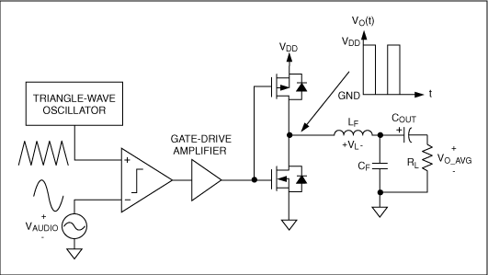
Figure 1. Basic diagram showing all the component parts of the circuit for a class D amplifier.

Overall information
In Table 1. Information regarding each class of amplifier is listed in the table. Efficiency will be described as a percentage of input power to output power. Fidelity will describe the quality of the audio that the amplifier can produce. Cost will describe how much each of the classes cost to make for a 5 W output.
Table 1. comparison of efficiency, cost, and quality
Class | Efficiency | Cost ($) | Fidelity
A | 25% | 50 | High
B | 50% | 40 | Medium
G | 60% | 80 | Medium-high
D | 95% | 20 | Low-medium

